DevOps project's photos & explanations
מגישים-
חן גוליאן, נוגה מנחם, אביב רום חורש וים רשף.

בס"ד
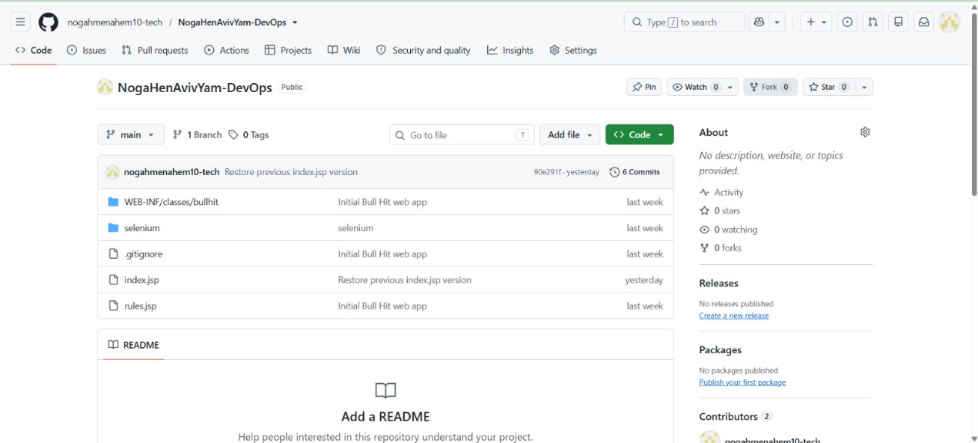
- Screenshot of your Github with the application/jsp in it:

- Screenshot of the application in our tomcat:
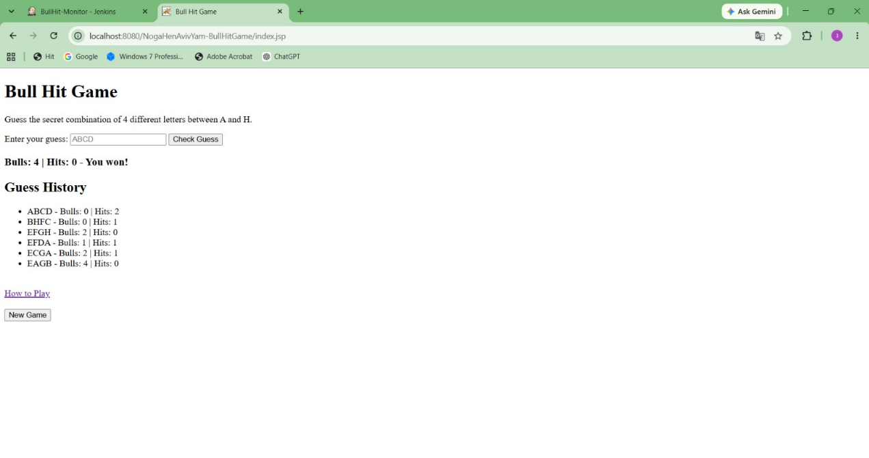
- A link to github public repo: https://github.com/nogahmenahem10-tech/NogaHenAvivYam-DevOps.git

- monitor tool we used: Jenkins
Role: monitor on up time.
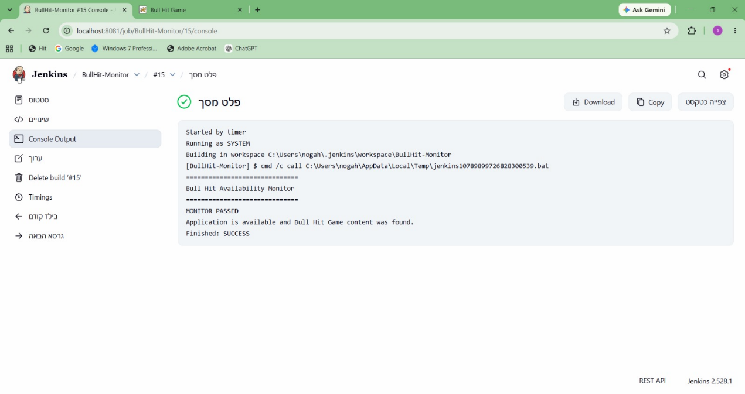
passed state-

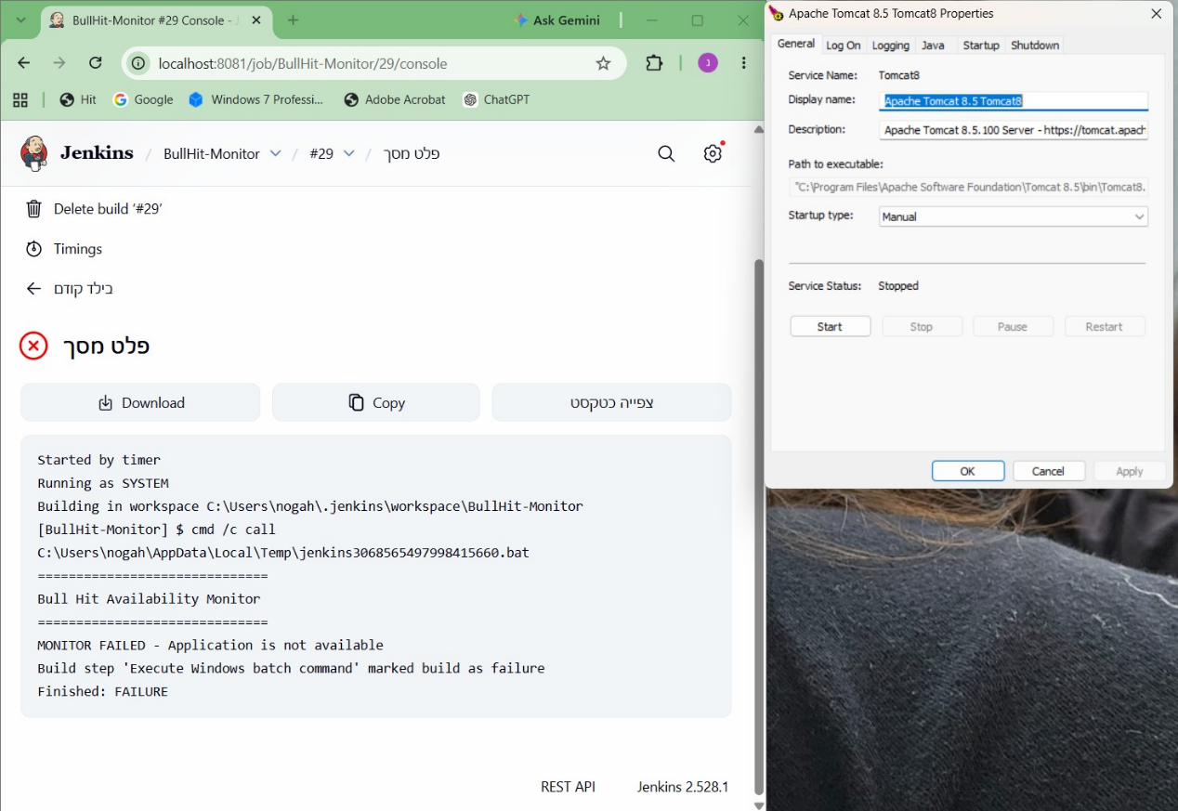
failed state-

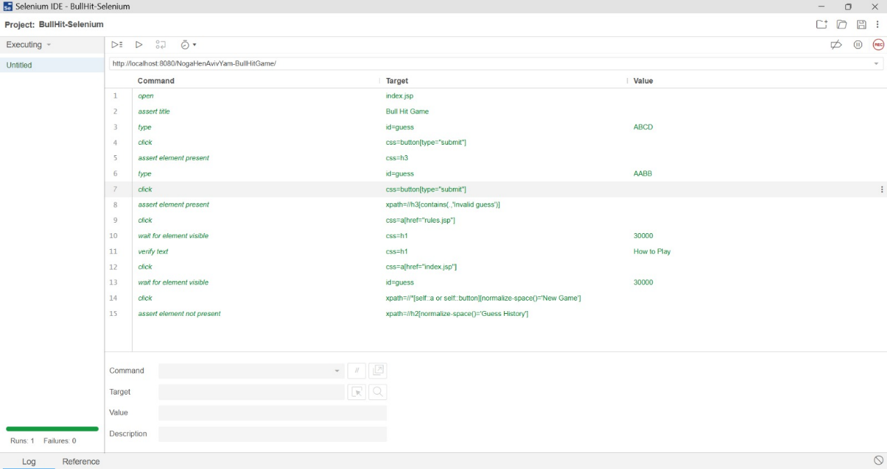
- Selenium IDE screenshot of passed run:
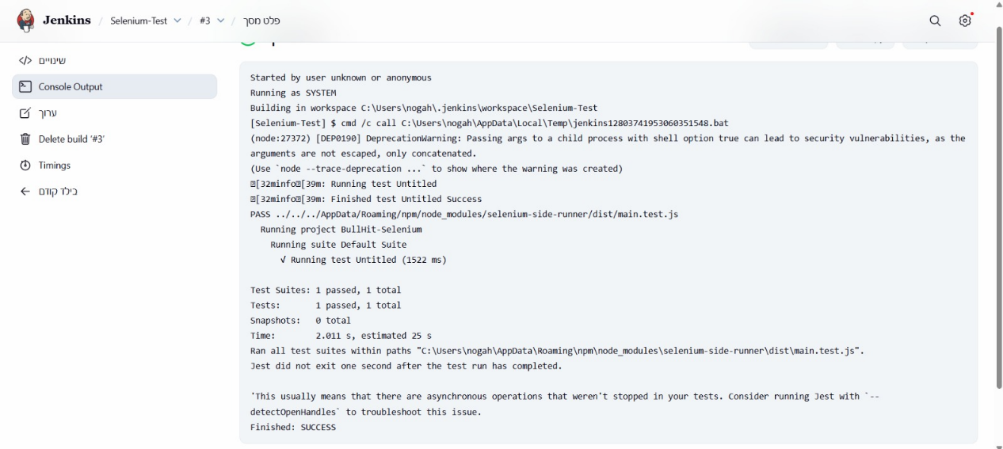

Our 5 validations:
Lines 1–2: verifying that the website loads correctly. Positive + Assert
Lines 3–5: Entering valid input (ABCD). Positive + Assert
Lines 6–8: Entering invalid input (AABB). Negative + Assert
Lines 9–13: Opening the game instructions and returning to the home page. Positive + Verify
Lines 14–15: Starting a new game. Positive + Assert

- Description of our HAR scenario in words:
opening the application → submitting a valid guess (ABCD) → submitting an invalid guess with duplicate letters (AABB) → opening the Rules page → returning to the game → resetting the game → submitting several different guesses (ABCD, EFAB, GHEF, GABH, GCDH, HCAE, CAEH) → resetting the game again.

- Our app max limit: 8292 users.
Our application's maximum limit is approximately 8292 concurrent users. We found this by gradually increasing the number of concurrent users with Gatling. A test with 8250 users completed without errors, while at 8,350 users the application started returning Connection refused errors. In that test, 8292 users were successfully handled before failures began. Therefore, we determined that approximately 8292 concurrent users is the application's maximum limit under our local test environment and test scenario.

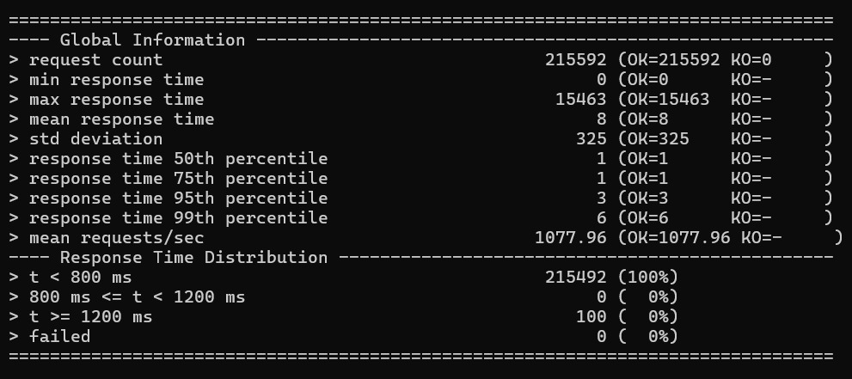
- max limit gatling run summary's screenshot:

- load gatling run summary's screenshot:
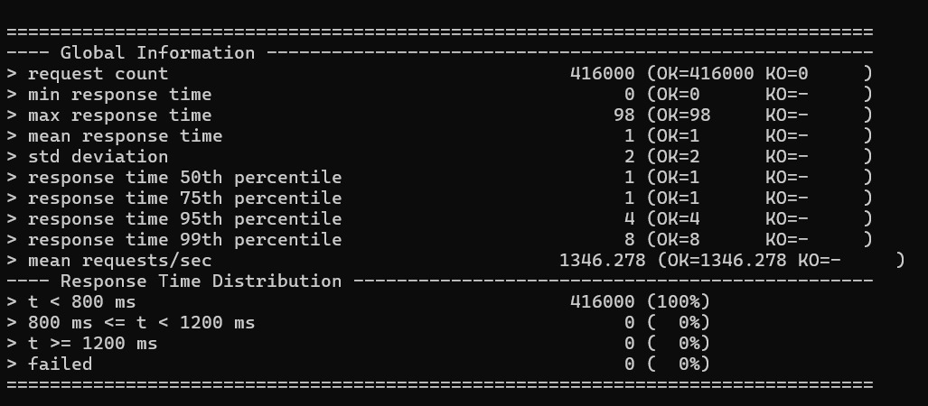

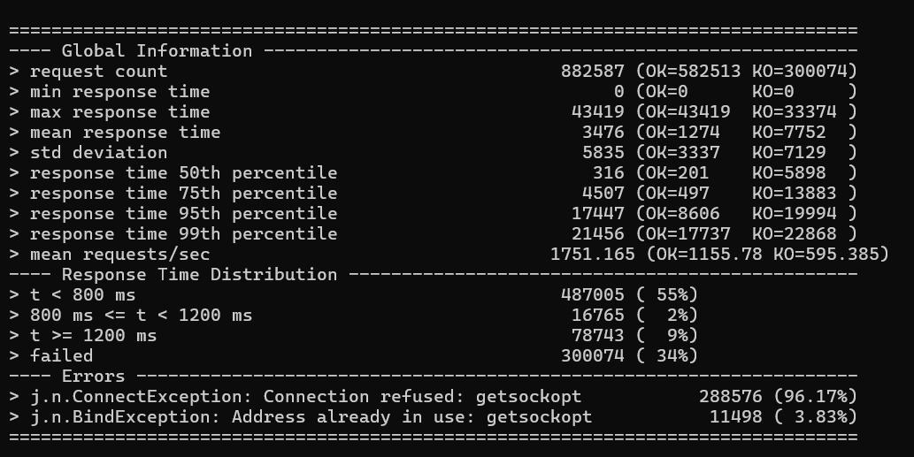
- stress gatling run summary's screenshot:

